WIRELESS POWER TRANSMISSION

USING TESLA COIL

***Submitted by***

|  |  |
| --- | --- |
| **ARUN RAAJ.GK** | **211420105304** |
| **AKRAM BASHA.A** | **211420105301** |
| **JOSHUA.E** | **211420105311** |
| **KRISHNAN.S** | **211420105314** |

***in partial fulfillment for the award of the degree of***

**BACHELOR OF ENGINEERING**

***in***

**ELECTRICAL AND ELECTRONICS ENGINEERING**



**PANIMALAR ENGINEERING COLLEGE**

**(An Autonomous Institution, Affiliated with Anna University, Chennai)**

**MAY 2023**

**PANIMALAR ENGINEERING COLLEGE**

**(An Autonomous Institution, Affiliated with Anna University, Chennai)**

**BONAFIDE CERTIFICATE**

Certified that this project report “ WIRELESS POWER TRANSMISSION USING TESLA COIL ” is the bonafide work of “ ARUN RAAJ.GK (211420105304), AKRAM BASHA.A (211420105301), JOSHUA.E (211420105311), KRISHNAN.S(211420105314)”who carried out the project Work under my supervision.

|  |  |
| --- | --- |
| **SIGNATURE** | **SIGNATURE** |
| **Dr. S. SELVI, M.E, Ph.D.** | **Dr. B.MUTHURAJ,M.E.,** |
| **Ph.D.** | |
| **HEAD OF THE DEPARTMENT** | **SUPERVISOR** |
| **PROFESSOR** | **ASSOCIATE PROFESSOR** |
| Department of Electrical and | Department of Electrical and |
| Electronics Engineering, | Electronics Engineering, |
| Panimalar Engineering College, | Panimalar Engineering College, |
| Chennai-600 123 | Chennai-600 123 |

Submitted for VI semester Mini Project Viva Voce held on .......................... at Panimalar Engineering College, Chennai**.**

**INTERNAL EXAMINAR EXTERNAL EXAMINAR**

**ACKNOWLEDGEMENT**

We would like to express our sincere thanks to our respected Chairman and Chancellor, Sathyabama University **Dr. JEPPIAR M.A., B.L., Ph.D.,** for being in the vanguard of scientific progress in our college.

We would like to express our deep gratitude to our Beloved Secretary and Correspondent **Dr. P.CHINNADURAI M.A., Ph.D.,** for extending his never-ending support to us.

We extend our sincere thanks to our Professor & Head of the Department, of Electrical and Electronics Engineering, **Dr. S. SELVI M.E, Ph.D.** and a heartfelt thanks to our Professor **Dr. D. SILAS STEPHEN M.E, Ph.D.** for his timely guidance on the technical front and for instilling immense confidence in us for completing our project successfully.

We are thankful and forever indebted to our Project Supervisor, **Dr. N. MANOJ KUMAR M.E, Ph.D.,** Professor for his insightful feedback and prompt assistance in completing our project.

We also extend our thanks to **All Staff Members** of Electrical and Electronics Engineering for their support and technical assistance. On a personal note, we would like to express our heartfelt thanks to our beloved **Parents** and our Friends, for their help and wishes in completing this project. Thanks to **Almighty** for giving us the strength to do this project successfully.

**ABSTRACT**

Electrical power is crucial to **modern** systems. From the smallest of sensors and bionic implants to satellites, remote-controlled airplanes/cars/robots, and oil platforms, it is important to be able to deliver power by means other than wires or transmission lines. The use of **wireless power transmission**, on a scale larger than used by magnetic induction devices, would allow for systems operate to remotely without the need for relatively large energy storage devices or routine maintenance. It will also be employed in cases where interconnecting wires are inconvenient, hazardous, or impossible such as in wet environments, rotating or moving joints as well as powering remote telecommunication equipment.

This paper explores the current wireless power transmission schemes and their practicability. It also delves into the theory, design, and construction of a method to transmit power through space. To this end, the solid-state tesla coil to the solid-state configuration is used as the basis to generate high-voltage, high-frequency electrical power.

Keywords—Wireless, Tesla coil, Electrical power, Induction.

**CHAPTER NO. TABLE OF CONTENTS PAGE NO.**

**TITLE**

|  |  |
| --- | --- |
| LIST OF FIGURES  LIST OF TABLES  ACKNOWLEDGEMENT  ABSTRACT  1. **INTRODUCTION** | iv  vi  01 |
| 1.1 Wireless power transmission using Tesla coil | 01 |
| 2. **LITERATURE SURVEY**  3. **EXISTING SYSTEM** | 05 |
| 4. **PROPOSED SYSTEM** | 10 |
| 3.1 Wireless transmission types | 10 |
| 3.2 Electric Power  3.2.1 Principle  3.2.2 Operation | 11 |
| 5. **SIMULATION EXPLANATION** | 13 |
| 5.1 High-Frequency Tesla Circuit | 13 |
| 6. **HARDWARE DESIGN** | 27 |
| 6.1 Component Used | 27 |
| 7. **CONCLUSION**  REFERENCES | 28 |

**CHAPTER 1**

**INTRODUCTION**

The idea of transmitting power through space was conceived over a century ago, with Nikola Tesla’s pioneering ideas and experiments perhaps being the most well-known early attempts to do so. His vision was to wirelessly distribute power over large distances using the earth’s ionosphere. Most approaches to wireless power transfer use an electromagnetic (EM) field of some frequency as how the energy is sent. At the high-frequency end of the spectrum are optical techniques that use lasers to send power via a collimated beam of light to a remote detector where the received photons are converted to electrical energy.

Efficient transmission over large distances is possible with this approach; however, complicated pointing and tracking mechanisms are needed to maintain proper alignment **between moving transmitters and** or receivers. In addition, objects that get between the transmitter and receiver can block the beam, interrupting the power transmission and, depending on the power level, possibly causing harm. At microwave frequencies, a similar approach can be used to efficiently transmit power over large distances using the radiated EM fiel**d from appropriate antennas.** However, similar caveats about safety and system complexity apply to these radiative approaches.

It is also possible to transmit power using non-radiative fields. As an example, the operation of a transformer can be considered a form of wireless power transfer since it uses the principle of magnetic induction to transfer energy from a primary coil to a secondary coil without a direct electrical connection. Inductive chargers, such as those found commonly in electric toothbrushes, operate on this same principle. However, for these systems to operate efficiently, the primary coil (source) and secondary coil (device) must be located nearby and carefully positioned around one another. From a technical point of view, this means the magnetic coupling between the source and device coils must be large for proper operation.

To overcome the above challenges, that is, to transmit somewhat larger distances or have more freedom in positioning the source and device relative to each other, this paper explores the use of a non-radiative approach that uses resonance to enhance the efficiency of the energy transfer to the miniature tesla coil.l [resonant transformer circuit](https://en.wikipedia.org/wiki/Resonant_transformer) designed by inventor [Nikola Tesla](https://en.wikipedia.org/wiki/Nikola_Tesla) in high

A **Tesla coil** is an arrival-voltage to high-voltage low-cure high-frequency electricity. Tesla experimented with several different configurations consisting of two, or sometimes three, couples.

Originally, Tesla coils used fixed spark gaps or rotary spark gaps to provide intermittent excitation of the resonant circuit; more recently, electronic devices are used to provide the switching action required. Tesla experimented with several different configurations and they consist of two, or sometimes three, coupled resonant electric circuits. Tesla used these coils to conduct innovative experiments in electrical lighting, phosphorescence, x-ray generation, high-frequency alternating current phenomena, electrotherapy, and the transmission of electrical energy without wires.

TESLA COIL DIAGRAM

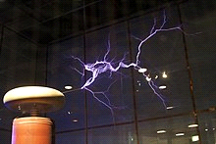

**CHAPTER 2**

**LITERATURE SURVEY**

*A. Historical Perspective*

• In 1864, James C. Maxwell predicted the existence of radio waves using a mathematical model.

• In 1884, John H. Poynting realized that the Poynting Vector would play an important role in quantifying electromagnetic energy.

• In 1888, bolstered by Maxwell's theory, Heinrich Hertz first succeeded in showing experimental evidence of radio waves with his spark-gap radio transmitter. The prediction and Evidence of the radio wave at the end of the 19th century was the start of wireless power transmission.

• Nikola started efforts on wireless transmission in 1891 at his “experimental station” in Colorado. A small incandescent resonant circuit, grounded on one end was successfully lighted.

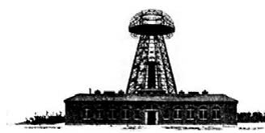

**Figure 1. Wardenclyffe Tower also known as Tesla’s tower (56.9 meters) at Long Island, New York**.

* Wardenclyffe Tower was designed by Tesla for trans-Atlantic wireless telephony and also for demonstrating wireless electrical power transmission.
* William C. Brown contributed much to the modern development of microwave power transmission which dominates research and development of wireless transmission today(figure 2). In the early 1960s brown invented the rectenna which directly converts microwaves to DC. Its ability was demonstrated by powering a helicopter solely through microwaves in 1964.[5]

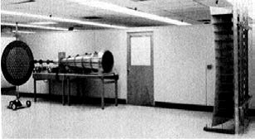

**Figure 2 Microwave power transmission laboratory experiment in 1975 by W. Brown**

A physics research group led by Prof. Marin Soljacic at the Massachusetts Institute of Technology (MIT) demonstrated wireless powering of a 60W light bulb with 40% efficiency at a 2m (7ft) distance using two 6ocm –diameter coils in 2007[6]. Resonant induction was used to transmit power wirelessly. The group is also working to improve the technology. The technology is currently referred to as WiTricity and to carry out this technology forward from the MIT laboratories, WiTricity Corp. was launched [6].

*B. Methods of Wireless Transmission of Electrical Power*

a. Near Field Techniques

i. Induction.

The principle of mutual induction between two coils can be used to transfer electrical power without any physical contact in between. The simplest example of how mutual induction works is the transformer, where there is no physical contact between the primary and the secondary coils. The transfer of energy takes place due to electromagnetic coupling between the two coils [7].

ii. Evanescent Wave Coupling.

This method uses non-radiative electromagnetic energy resonant tunneling. Since the electromagnetic waves tunnel through the air, energy absorption by air is eliminated and electronic devices are not disrupted. Unlike electromagnetic radiation, it is not considered harmful to the human body.

iii. Air ionization

The concept here is the ionization of air due to the electromagnetic field produced. This technique exists in nature and its implementation requires high fields of about 2.11 MV/m. Richard E. Vollrath, a California inventor has developed an ingenious sand-storm generator, which sends blasts of dust-laden air through copper tubes, generating electricity that can be stored in a sphere

iv. Electrodynamic Induction

This method is also known as "resonant inductive coupling" and it resolves the main problem associated with non-resonant inductive coupling for wireless energy transfer; specifically, the dependence of efficiency on transmission distance. When resonant coupling is used the transmitter and receiver inductors are tuned to a mutual frequency and the drive current is modified from a sinusoidal to a non-sinusoidal transient waveform. The pulse power transfer occurs over multiple cycles. In this way, significant power may be transmitted over a distance of up to a few times the size of the transmitter.

v. Electrostatic Induction.

This method is also known as “capacitive coupling". It is an electric field gradient or differential capacitance between two elevated electrodes over a conducting ground plane for wireless energy transmission. It involves high-frequency alternating current potential differences transmitted between two plates or nodes.

b. Far Field Techniques

Far Field Energy Transfer is mainly dependent on radiative techniques. Waves are either broadcasted in the form of narrow beam transmission of radio, or light waves. This is solely for high power transfer. Tesla already gave the concept to the world in his paper: “Truly Wireless” in the late 1880s based on the Wardenclyffe Tower which was constructed to trans energy for large distances [4].

i. Radio and Microwave

Power transmission via radio waves can be made more directional, allowing longer-distance power beaming, with shorter wavelengths of electromagnetic radiation, typically in the microwave range. A rectenna may be used to convert microwave energy back into electricity. Rectenna conversion efficiencies exceeding 95% have been realized [9]. Power beaming using microwaves has been proposed for the transmission of energy from orbiting solar power satellites to Earth and the beaming of power to spacecraft leaving orbit has been considered.

ii. Electromagnetic Transmission

Electromagnetic waves can also be used to transfer power without wires. By converting electricity into light, such as a laser beam, then firing this beam at a receiving target, such as a solar cell on a small aircraft, power can be beamed to a single target[10].

LASER Technology uses the same principle as microwave wireless transmission but here energy emission is of high frequency and is coherent. The other great advantage of LASER power transmission is the aperture collection efficiency. The antenna can be made small due to the collimation of the beams. LASER transmission does not get dispersed for long distances but it gets attenuated when it propagates through the atmosphere.

*C. Need for Wireless Power Transmission*

Wireless transmission is employed in cases where instantaneous or continuous energy transfer is needed, but interconnecting wires are inconvenient, hazardous, or impossible (figure 3).

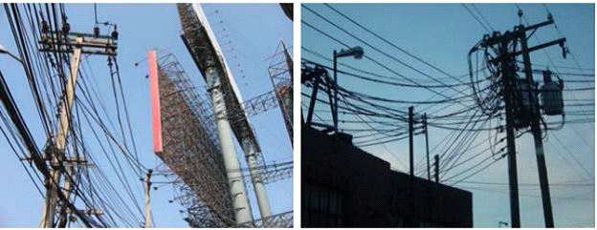

**Figure 3 Interconnected wires**

Several household points receive electricity at the same frequency using a single transmitting coil as long as they all are at resonance (figure 4).

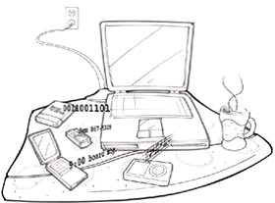

**Figure 4 Household points receiving electricity from one coil**

*D. Technology Benefits and Applications*

The interest in highly resonant wireless power transfer comes from many markets and application sectors. There are several motivations for using such technology, and these often fall into one or more of the following categories:

• Make devices more convenient and thus more desirable to purchasers, by eliminating the need for a power cord or battery replacement.

• Make devices more reliable by eliminating the most failure-prone component in most electronic systems—the cords and connectors [10].

• Make devices more environmentally sound by eliminating the need for disposable batteries. Companies make about 40 billion disposable batteries each year, and wireless electricity could do away with that [11]. Using grid power is much less expensive and more environmentally sound than manufacturing, transporting, and using batteries based on traditional electro-chemistries.

• Reduce system cost by leveraging the ability to power multiple devices from a single source resonator.

• Charging will likely become possible for mobile devices from different manufacturers via wireless charging pads in public spaces such as cafés, airports, taxis, offices, and restaurants.

• LED (light emitting diode) lights can be directly powered with wireless electricity, eliminating the need for batteries in under-cabinet task lighting, and enabling architectural lighting designers to create products that seemingly float in mid-air, with no power cord[12].

• The unmanned planes or robots (where wires cannot be involved viz: oceans, volcanic mountains, etc.) which are run by wireless power over an area, as they could fly for months at a time, could be used for research.

*E. Solid State Tesla Coil (SSTC)*

It is an air-cored resonant transformer capable of generating extremely high voltages. Its construction is relatively straightforward. The key concept of a Tesla Coil is its resonant property, where a Resistor-Inductor-Capacitor (RLC) resonant circuit is energized at its resonant frequency, developing very high voltages [13].

A Tesla Coil consists of two concentric coils which are not electrically connected. The Primary Coil usually consists of a few turns of heavy wire and has a shape ranging from a solenoid to a flat spiral. This coil is usually connected to some capacitor, forming the Primary LC circuit. The secondary circuit consists of a long coil of wire, usually having several hundreds to thousands of turns wound on a pipe, and placed concentrically in the middle of the coil [14]. The control circuit consists of solid-state devices.

**CHAPTER 3**

**EXISTING SYSTEM**

Transmitting electricity at high voltage reduces the fraction of energy lost to resistance, which varies depending on the specific conductors, the current flowing, and the length of the transmission line.

Factors that affect the resistance, and thus loss, of conductors used in transmission and distribution lines include temperature, spiraling, and the skin effect. The resistance of a conductor increases with its temperature. Temperature changes in electric power lines can have a significant effect on power losses in the line. Spiraling, which refers to the way stranded conductors spiral about the center, also contributes to increases in conductor resistance.

The skin effect causes the effective resistance of a conductor to increase at higher alternating current frequencies. Corona and resistive losses can be estimated using a mathematical model.

**CHAPTER 4**

**PROPOSED SYSTEM**

The principles behind the Tesla coil are relatively simple. Just keep in mind that electrical current is the flow of electrons, while the difference in electric potential (voltage)between two places is what pushes that current. Current is like water, and voltage is like a hill. A large voltage is a steep hill, down which a stream of electrons will flow.

A small voltage is like a near-flat plain with almost no water flow. The power of the Tesla coil lies in a process called electromagnetic induction, i.e., a changing magnetic field creates an electric potential that compels current to flow. Conversely, flowing electric current generates a magnetic field. When electricity flows through a wound-up coil of wire, it generates a magnetic field that fills the area around the coil in a particular pattern. Similarly, if a magnetic field flows through the center of a coiled wire, a voltage is generated in the wire, which causes an electrical current to flow.

The electric potential (“hill”) generated in a coil of wire by a magnetic field through its center increases with the number of turns of the wire. A changing magnetic field within a coil of 50 turns will generate ten times the voltage of a coil of just five turns. (However, less current can flow through the higher potential, to conserve energy.) This is exactly how a common alternating current (AC) electrical transformer, found in every home, works. The constantly fluctuating electric current flowing in from the power grid is wound through a series of turns around an iron ring to generate a magnetic field. Iron is magnetically permeable, so the magnetic field is almost entirely contained in the iron.

The ring guides the magnetic field (in green below) around and through the center of the opposite coil of wire. Flying blue streamers of electrons flow off the coil and through the hot air searching for a conductive landing place. They heat the air and break it into a plasma of glowing ion filaments before dissipating into the air or surging into a nearby conductor.

**Tesla Coil Working**:

This coil uses a specialized transformer called a resonant transformer, a radio-frequency transformer, or an oscillation transformer. The primary coil is connected to the power source and the secondary coil of a transformer is coupled loosely to ensure that it resonates. The capacitor connected in parallel with the transformer circuit acts as a tuning circuit or an LC circuit to generate signals at a specific frequency. The primary of the transformer, otherwise referred to as a resonant transformer steps up to generate very high levels of voltage ranging between 2kv to 30 kV, which in turn charges the capacitor. The accumulation of massive amounts of charge in the capacitor, eventually, breaks down the air of the spark gap. The capacitor emits a huge amount of current through the Tesla Coil (L1, L2), which in turn generates a high voltage at the output.

**CHAPTER 5**

**SIMULATION EXPLANATION**

**5.1 High-Frequency Tesla Circuit**

Tesla, probably the highest authority in high-frequency electrical engineering today, has not been dreaming these past few years, although we have not heard much from him, except through the daily newspapers, which now and then publish some world-startling interview describing a “marvelous” Tesla wave with which it is possible to communicate with Mars and several hundred other astounding stunts that the winner of the Noble physics prize probably never even thought of, much less attempted to accomplish.

Most of our readers have, no doubt, seen pictures of the famous Tesla wireless tower located at Shoreham, Long Island, and which structure has involved the expenditure of a vast sum of money. This lofty structure, which was designed in the neighborhood 20 years ago by Dr. Tesla and his associates, there was to be propagated an electric wave of such intensity that it could charge the earth to such an extent that the effect of the wave or charge could be felt in the utmost confines of the globe.

Our front cover illustration shows the Tesla tower in (theoretical) operation and, in line with some of the latest statements from this marvelous man, there may be perceived as several dreadnoughts being blown to atoms, which is due to the high tension electric wave sent out from this center of vast electrical activity. Tesla, for obvious patent reasons, does not go into details about just how whole fleets of a hostile navy can be destroyed in this way using powerful electric waves, but quite possibly he has in mind the fact that the latter can be tuned, undoubtedly to a particular wave of certain frequency and power to accomplish this result when liberated from such a mighty station or oscillator as that located on Long Island. Such ships as the great steel shell dreadnoughts of today would, of course, have a large electrical capacity and this would help out the Tesla theory which covers the transmission and reception of an electric wave of sufficient intensity to do great good or damage, as the case might be.

**CHAPTER 6**

**HARDWARE DESIGN**

A solid-state tesla coil usually has these key components:

• Power source.

• Switching circuit. The circuits that make the Tesla coil work at the correct frequency and duty cycle.

• Primary coil. The primary coil (figure 5) is powered by the control circuitry and generates the magnetic field that the secondary use to create the high voltage. It is the few turns of thick wire at the base of the secondary coil.

• The Top load: The top load is the metallic object at the top of the secondary coil. It provides capacitance to the Tesla coil.

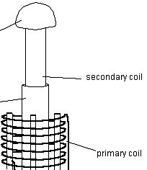

**Figure 5 Secondary and primary coils.**

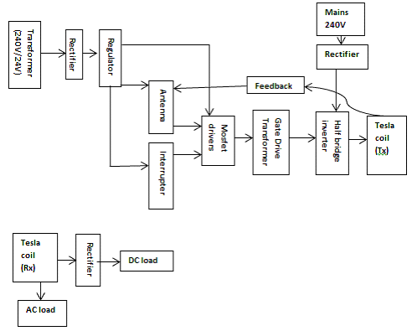

**Figure 6 Functional block diagram**

It shows how the system modules relate to one another.

*A. System Modules*

• Two power supplies are provided-One that power the Tesla coil switching circuit and the other the primary coil (Figure 6).

• The Interrupter (Figure 7) turns to turn the Tesla coil on and off at a certain frequency. This doubles as a power control if the duty cycle of the circuit is varied.

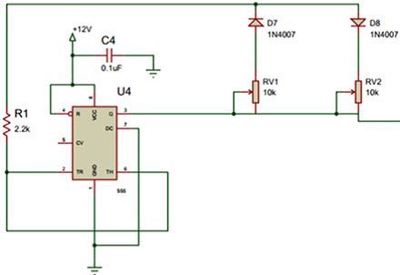

**Figure 7 The Interrupter**

* Antenna section. It is the feedback mechanism (figure 8). This part of the circuit is designed to capture feedback from the secondary coil to keep the circuit resonating. The antenna could be any straight piece of wire connected to the circuit. The other end is left unconnected.

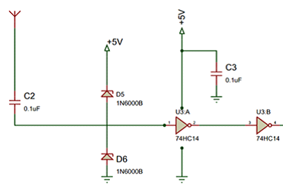

**Figure 8 Antenna section**

A solid-state Tesla coil works by switching the primary coil at a resonant frequency. This frequency varies due to the height of the coil, the top load, and the environment [14]. Thus, a fixed frequency oscillator is not ideal.

The used driver changes its frequency based on what the antenna receives from the Tesla coil. Antenna feedback is designed to capture feedback from the secondary to keep the circuit resonating. Because we use feedback to provide the signal to the half-bridge, the coil is always in tune. Using Schottky diodes (diodes with a low forward voltage drop, and hence, fast) to clamp the signal to ground and +Vcc, to ensure the drive is not destroyed; a square signal to the driver input is obtained.

Gate drive. This part of the circuit combines and amplifies the interrupter and feedback signals to drive the gate drive transformer (figure 9). The circuit works by generating a square wave from the respective outputs of the inverting and non-inverting MOSFET drivers and they operate in phases.

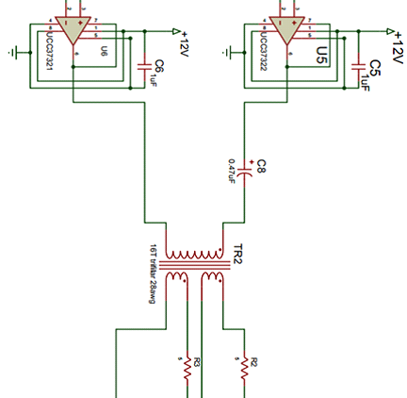

**Figure 9 Gate drive**

* Gate drive transformer. Isolates the switching circuit (figure 10).

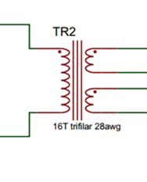

**Figure 10 Gate drive**

* Half bridge Inverter. These are two MOSFETs that alternate switching on and off to produce alternating current (figure 11). This is done at a high voltage, mainly so that power can be pumped through the primary coil. This causes a magnetic field to be formed that excites the secondary coil (resonator).

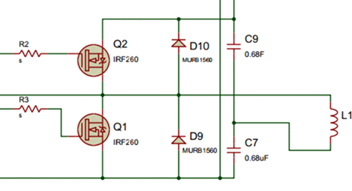

**Figure 11 Half bridge Inverter**

* Two Tesla coils; Transmitter and receiver.

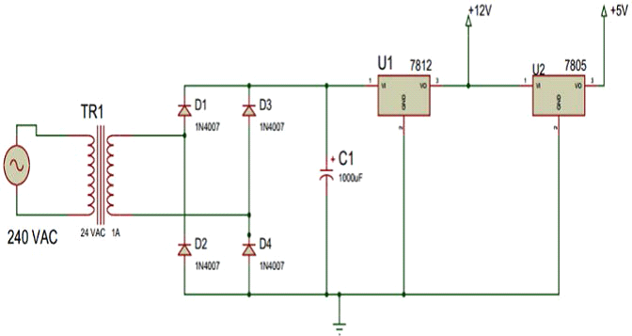

**Figure 12 Power supply to control circuit**

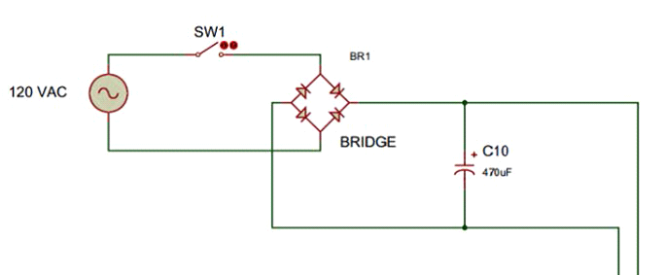

**Figure 13 Power supply to the half-bridge**

**6.1 Component Used**

**Door knob**

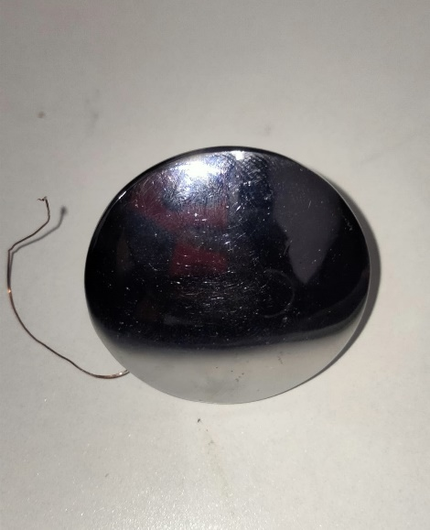

A doorknob is the [knob](https://www.dictionary.com/browse/knob) or handles used to open and close a door.

Doorknobs are common on doors, especially the inside doors of a home, such as the doors of different rooms and closets. These tend to be metal and shaped like a, well, knob—a part that sticks out and has a rounded end. [Door handles](https://www.dictionary.com/browse/door-handle) in other shapes might be called doorknobs, but it’s more likely for them to be called door handles or just handles.

Another difference is that doorknobs typically turn. Door handles can turn, but they can also be fixed in place, like a vertical or horizontal bar.

A doorknob may also have a lock or keyhole to lock the door with.

Example: The mansion was so luxurious that even the doorknobs were made of solid gold.

**2.) 32 GAUGE COPPER WIRE**

32 SWG Super Enameled Copper Winding Wire For Transformers, Inductors, Electromagnets, Solenoids, Motors, Generators, Speakers, etc.  
**Wire Gauge:** 32 SWG, **Overall Diameter:** 0.299mm ±0.007mm, **Resistance Per Meter:** 0.292 Ohm Approximate, **Current Capacity:** 233mA Approximate, **Length:** 1 Meter (multiple quantities will get continuous one long piece).  
**Note:** If you plan to make a DC electromagnet, require an approximate volts wire length of 15 Meters (for 5V DC 5x15=75 Mtrs).

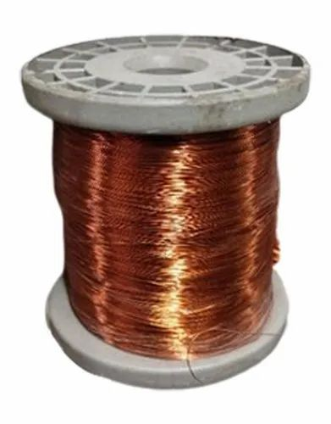

**3.)PVC PIPE**

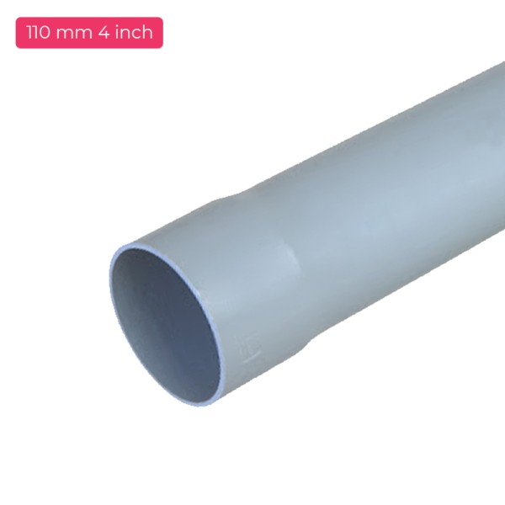

Arguably one of the most universal and versatile types of plastic piping, PVC pipes have been in use for over 80 years, servicing a multitude of applications in various market sectors around the world. Compared to metal piping, PVC pipes are exceptionally strong and durable, with complete corrosion resistance and with little risk of succumbing to thermal expansion or contraction. Economical and robust, these pipes come in various sizes with a range of available fittings and can be used for both warm or cold water applications depending on the type of PVC variant.

CHAPTER 7

CONCLUSION

The main objective of this paper was to demonstrate wireless power transmission using solid-state Tesla coils. Tesla coils are remarkable devices able to generate high-voltage, high-frequency waveforms with little control circuitry. Most of the builders of Tesla coils are interested in producing electric arcs and visible effects suitable for displays and general amusement, not in producing power supplies and power effects units that may have significant practical importance. The paper has demonstrated that Tesla coils can be designed for wireless power transmission.

Further improvements to be made to the design include:

• Design of a full wave inverter to power the Tesla coils. This will minimize the losses since full-wave inverters do not exhibit the losses prevalent in half-wave rectifiers.

• A better feedback mechanism can be adopted instead of using a wire. A small current transformer on the secondary coil can be used, instead, to obtain feedback. This is constructed by wrapping around 50 turns of wire on a small ferrite core with the secondary wire going through this ring on the ground side. Care must be taken to ensure the right phasing.

**REFERENCES**

[1] Nicola Tesla, “The transmission of electrical energy without wires”, Electrical World and Engineer, March 1905.Available:http://www.tfcbooks.com/tesla/1904-03-05.htm, (acc. May. 2014).

[2] William C. Brown, “The history of power transmission by radio waves”, Microwave Theory and Techniques, IEEE Transactions, 32(9):1230-1242, September 1984.

[3] J. C. Maxwell, A Treaty of Electricity and Magnetism, 1st ed. New York, U.S.A.: Cambridge University Press, 1873.

[4] Nikola Tesla, "The Transmission of Electrical Energy Without Wires as a Means for Further Peace," Electrical World and Engineering, p. 21, January 7, 1905.

[5] William C. Brown and E. Eugene Eves, "Beamed Microwave Power Transmission and its Application to Space," IEEE Transactions on Microwave Theory and Techniques, vol. 40, no. 6, pp. 1239-1250, June 1992.

[6] Franklin Hadley. (2007, June) MIT news: Goodbye wires. Available: <http://newsoffice.mit.edu/2007/wireless-0607>. (acc. Feb. 2015).

[7] “Wireless energy transfer” Wikimedia Foundation, Inc. <http://en.wikipedia.org/wiki/> Wireless_energy_transfer.

[8] Edwin Teale, "New Discoveries Shows Electricity Governs our Lives," Popular Science, vol. 124, no. 2, p. 11, February 1934.

[9] William C. Brown and E. Eugene Eves, "Beamed Microwave Power Transmission and its Application to Space," IEEE Transactions on Microwave Theory and Techniques, vol.40, no. 6, pp. 1239-1250, June 1992.

[10] Mohammed, S., Ramasamy, K., & Shanmuganantham, T. (2010). Wireless Power Transmission - A Next Generation Power Transmission System. International Journal Of Computer Applications, 1(13), 102-105. doi 10.5120/274-434.

[11] A cordless future for electricity? - CNN.com. Available: <http://edition.cnn.com/2009/TECH/09/02/wireless.electricity/index.html>? iref=nextin. (acc.Feb 2015).

[12] Kesler, M. (2013). Witricity (1st ed.). Retrieved from <http://www.witricity.com/assets/highly-resonant-power-transfer-kesler-witricity-2013.pdf>

[13] Craven, R. (2014). A study of secondary winding designs for the two-coil Tesla transformer (PhD.). Loughborough University.

[14] Johnson, G. (2001). SOLID STATE TESLA COIL (1st ed.). Manhattan. Retrieved from <http://www.g3ynh.info/zdocs/refs/Tesla/Johnson2001_ssTeslacoil.pdf>.

[15] R.G.Medhurst. High-frequency resistance and self-capacitance of single-layer solenoids. Wireless Engineer, 24(281):35-43, Feb.1947